NON TEACHING STAFF PROFILE
Name of the Technical Staff
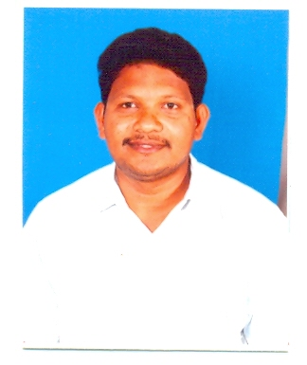
Department: Electronics &communication Engineering
College: Gudvalleru Engineering college
Phone No:
Mobile: 9908998083
E-Mail: srinu143.mopidevi @gmail.com

----------------------------------------------------------------------------------------------------
Academic Qualifications
S. No | Name of the Degree  (Starting from Higher Degree to 10th Class) | University | Percentage of Marks/Grade | Specialization | Year of Pass
1 | B.sc | AcaryaNagarjuna  university | 58.5% | Electronics | 2014
2 | ITI | National Trade Certificate | 63.8% | Electronics | 1995
3 | SSC | State Board of Education | 53.7% | -- | 1993
Professional Experience
S. No | Designation | Institution Name | Working Period
S. No | Designation | Institution Name | From | To
1 | Lab Technician | Gec, Gudlavalleru | 2008 | Till date
2 | Lab Assistant | Skec, Khammam | 2002 | 2008
Professional Body Membership
S. No | Name of the Professional body | Membership Number
1 | Member of Indian Society for Technical Education | LM 45078

Workshops Organized No.:
1. Attended in two-day workshop on Design and differentiate sensors in embedded application organized by EEE department gudlavalleru engineering college during 14-15 march, 2014.
2 Attended in one week refresher course on pulse and digital circuits theory and lab practice during 21-26 November 2011 organized by the department of electronics and communication engineering.
3 We have organized the one day workshop on maintenance of electronics lab equipment during the 26th January 2015 department of electronics and communication engineering.
4 Attended in two day workshop on High Frequency Structure Simulator (HFSS) during the 29th and 30th August 2019 at Gudlavalleru Engineering College

Workshops /Conferences /Seminars Attended No.:
- Participated in Two-Day FDP on “Design of Integrated Circuits using Micro Wind Tools” organized by Department of Electronics and Communication Engineering, at Seshadri Rao Gudlavalleru Engineering College, Gudlavalleru during 30th to 31st August 2023.
- Attended in workshop on maintenance of electronics Lab equipment 06th department of electronics communication engineering of Siddhartha engineering college Vijayawada

.
Certifications/Training Programs Attended No. :
1. Diploma in Electronics &Computer Hardware Engineering. (D.E.C.H.E)
2.Post graduation Diploma in computer Application. (PGDCA)

Labs Handled: 1.Micro wave & optical communication Lab
2.Eletronics & devices circuits
3.Analog communication Lab

College Level
1.Gec festival committee work
2. LCD system Maintenance Work

Department Level
1.Examination paper work
2. Lab Euipment Maintenance work

Declaration
I hereby declare that all the above-furnished information is correct to the best of my knowledge.

Date: Signature
Place: (M. SRINIVAS)

